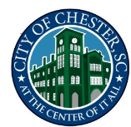

Special Called Council Meeting

September 19, 2023 – 7:00 pm
In Person &Virtual

Minutes

PRESENT: Members of Council: David Claytor, Danielle Hughes, Ursula Boyd-Crosby, and Robbie King-Boyd

ABSENT: Mayor Carlos Williams. Members of Council: Wade Young, Tabatha Strother, Tony Nelson, and Jamie Price. Staff: Malik Whitaker

No Quorum

Respectfully Submitted,

Marquita Fair
Municipal Clerk

